Final Report.

*Introduction*

As a group we chose to stick with the original concept of RogueRun, despite there being some name changes the basic premise was always the same. An action-adventure car shooting game where the player had to overcome waves of enemies in order to progress.

We had other ideas such as having dynamic levels i.e. timed survival waves, point capped waves etc. but these would theoretically be implemented in other levels where appropriate to the story.

*Project Management*

In order to work in an agile development cycle, we would recap what everyone was doing, had done and what we needed help with using the Project tab on our GitHub repo (<https://github.com/nike-sh/CarProto>).

The sprint review is as follows:

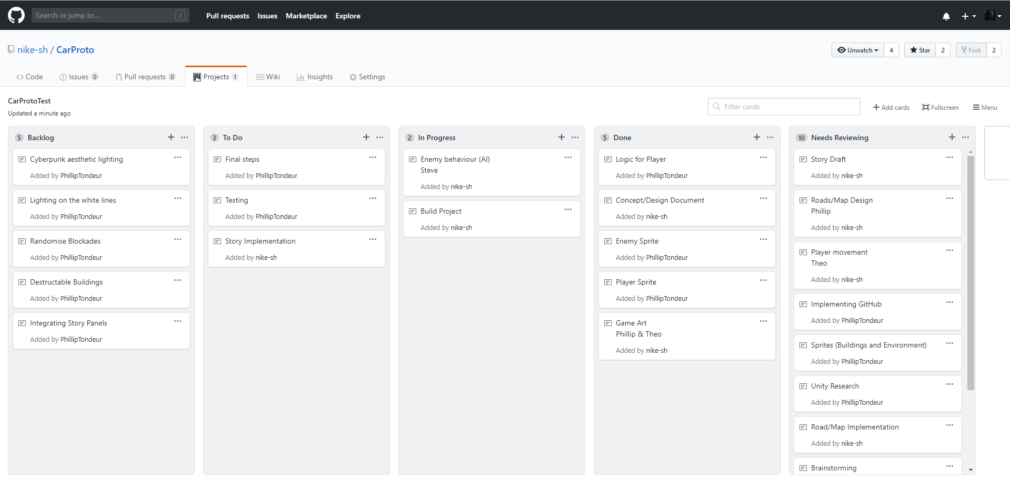

We decided to use GitHub since the local and remote repo would help us collaborate from across desks/home.

Our group regularly met around 2-3 times a week. Recording how much time we spent working by timing how long we spent on projects (such as AI, audio etc.).

*Implementation*

p